// ASHISH SAXENA
Connecting to the Unix Server

- Connecting to the Unix Server
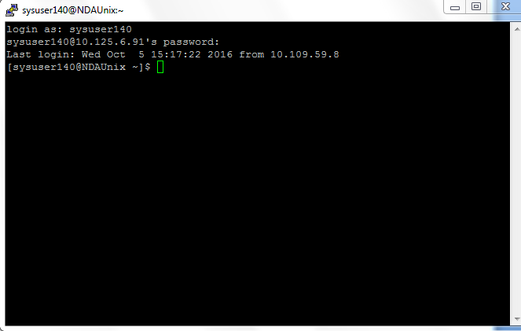

- Logging out of the system
